**SQL for Business Analyst (Skill Track)**

**Exploratory Data Analysis in SQL**

**Chapter1**

* Explore SQL database
* Summarize data
* Clean a messy data

**Database client** = The program to connect to, work with, a database

* **A screenshot of a computer

  Description automatically generatedEntity-relationship** diagram (**schema)**:
* Company_id : id means, foreign keys from one table to another table
* Company_id : id means, foreign keys from one table to another table
* Parent_id : id means, foreign keys reference a column in the same table
* If there is not any foreign key, ir doesn’t prevent us from joining them

* Note that COUNT() only counts the non-null values

**The keys to the database**

Understanding formal relationships, or links between tables (Foreign keys)

Example:

**Table: Employees**

| **FirstName** | **MiddleName** | **LastName** |
| --- | --- | --- |
| John | NULL | Doe |
| Jane | Alice | Smith |
| Robert | NULL | Brown |
| Emily | Marie | Johnson |

**SQL Query Using COALESCE**

SELECT

FirstName,

COALESCE(MiddleName, LastName) AS PreferredName

FROM

Employees;

**Result**

| **FirstName** | **PreferredName** |
| --- | --- |
| John | Doe |
| Jane | Alice |
| Robert | Brown |
| Emily | Marie |

In this result:

* For John, since MiddleName is NULL, COALESCE uses LastName (Doe).
* For Jane, MiddleName (Alice) is used since it’s not NULL.
* For Robert, MiddleName is NULL, so LastName (Brown) is used.
* For Emily, MiddleName (Marie) is used directly.
* **Foreign keys** reference another row in the database via a unique ID. Values in a foreign key column are restricted to values in the referenced column OR NULL.

A **foreign key** in a database is a column (or set of columns) in one table that references the **primary key** of another table (or even the same table). It enforces a link between the data in the two tables, ensuring that values in the foreign key column must either:

1. Match an existing value in the referenced (primary key) column of another table.
2. Be NULL if the relationship allows it (meaning there's no reference).

**Simple Example**

Imagine you have two tables in a database: **Customers** and **Orders**.

**Customers Table**

| **customer_id (Primary Key)** | **customer_name** |
| --- | --- |
| 1 | Alice |
| 2 | Bob |
| 3 | Charlie |

* customer_id is the **primary key** of the Customers table. Each customer has a unique ID.

**Orders Table**

| **order_id** | **customer_id (Foreign Key)** | **order_amount** |
| --- | --- | --- |
| 101 | 1 | 200 |
| 102 | 2 | 150 |
| 103 | 4 | 300 |
| 104 | NULL | 250 |

* customer_id in the Orders table is a **foreign key** that references customer_id in the Customers table.
* This means that values in the Orders.customer_id column should only contain values found in Customers.customer_id, or be NULL.

**Explanation**

1. Row 1 in Orders has customer_id = 1, which is valid because 1 exists in Customers.
2. Row 2 has customer_id = 2, also valid.
3. Row 3 has customer_id = 4, which is **invalid** because there’s no customer_id = 4 in Customers.
4. Row 4 has customer_id = NULL, which is **allowed** if the foreign key constraint permits NULL values.

In summary, the foreign key constraint helps ensure that each customer_id in Orders either points to an existing customer in Customers or is NULL.

**Column Types and Constraints**

* Reminder: for converting the type use CAST(), use can either use it for the value or the column

**OR:**

Examples:

-- Select the original value

SELECT profits_change,

        -- Cast profits_change

       CAST( profits_change AS integer) AS profits_change_int

  FROM fortune500;

-- Divide 10 by 3

SELECT 10/3,

       -- Cast 10 as numeric and divide by 3

       10::numeric/3;

SELECT '3.2'::numeric,

       '-123'::numeric,

       '1e3'::numeric,

       '1e-3'::numeric,

       '02314'::numeric,

       '0002'::numeric;

**Chapter2**

**Summarizing and Aggregating Numeric Data**

**Numeric Data Types and Summary Functions**

* Columns and variables (whole number and decimals)
* Serials are integer columns that autoincrement (For ID columns)

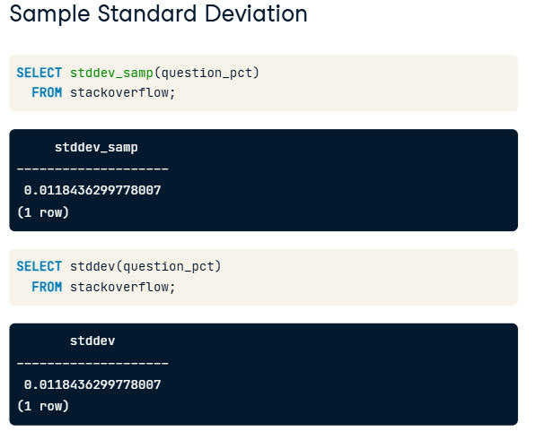

**Exploring distributions**

* Crucial for finding errors, outliers and other anomalies in data

* **How to make a bigger groups include more data?**
  + Truncate function: Reduce the precision of a number, replacing the smallest numeric places, the right-most digits- with zeros.

* + Different from Round, it only gets rid of the extra characters.
  + The second argument, positive amounts, truncates after decimals, and negative one truncates before decimals from real values.
* **Solution:**

**PAY ATTENTION!**

The SQL query execution order is indeed as follows:

1. FROM
2. WHERE
3. GROUP BY
4. HAVING
5. SELECT
6. ORDER BY

However, **aliases defined in the SELECT clause can still be used in GROUP BY and ORDER BY**. This is because SQL engines have an optimization phase where they recognize column aliases from SELECT and allow them to be referenced in GROUP BY and ORDER BY, even though SELECT logically comes later.

In other words, SQL engines "rewrite" or parse the query so that these references to aliases in GROUP BY and ORDER BY are resolved correctly, even if they appear out of logical order. This is an exception to the strict execution order to make SQL queries easier to write and read.

* How to make a smaller and desired size of the group? Making Series

* Now making bins for the dataset:

* The solution is to making sub-quiries as below:

**More Summary Functions**

* Finding relationships between columns (correlation -1< <1) on top of the summary like counting

Example codes:

-- What groups are you computing statistics by?

SELECT sector,

       -- Select the mean of assets with the avg function

       avg(assets) AS mean,

       -- Select the median

       percentile_disc(0.5) WITHIN GROUP (ORDER BY assets) AS median

  FROM fortune500

 -- Computing statistics for each what?

 GROUP BY sector

 -- Order results by a value of interest

 ORDER BY mean;

**Creating Temporary Tables**

* First one is recommended and allows to use option not available with the “select into”

* Notice in different editors, it would be shown how many columns have been added.
* Titles should be match with the one in the table to be added

* The table will be deleted without any warning
* Temporary will be deleted when you disconnect from the database

* It doesn’t stop the query if it doesn’t exist

Example code:

DROP TABLE IF EXISTS correlations;

CREATE TEMP TABLE correlations AS

SELECT 'profits'::varchar AS measure,

       corr(profits, profits) AS profits,

       corr(profits, profits_change) AS profits_change,

       corr(profits, revenues_change) AS revenues_change

  FROM fortune500;

INSERT INTO correlations

SELECT 'profits_change'::varchar AS measure,

       corr(profits_change, profits) AS profits,

       corr(profits_change, profits_change) AS profits_change,

       corr(profits_change, revenues_change) AS revenues_change

  FROM fortune500;

INSERT INTO correlations

SELECT 'revenues_change'::varchar AS measure,

       corr(revenues_change, profits) AS profits,

       corr(revenues_change, profits_change) AS profits_change,

       corr(revenues_change, revenues_change) AS revenues_change

  FROM fortune500;

-- Select each column, rounding the correlations

SELECT measure,

       ROUND(profits :: numeric,2) AS profits,

       ROUND(profits_change:: numeric,2) AS profits_change,

       ROUND(revenues_change:: numeric,2) AS revenues_change

  FROM correlations;

**Chapter3**

**Character data types and common issues**

* Exploring character and text

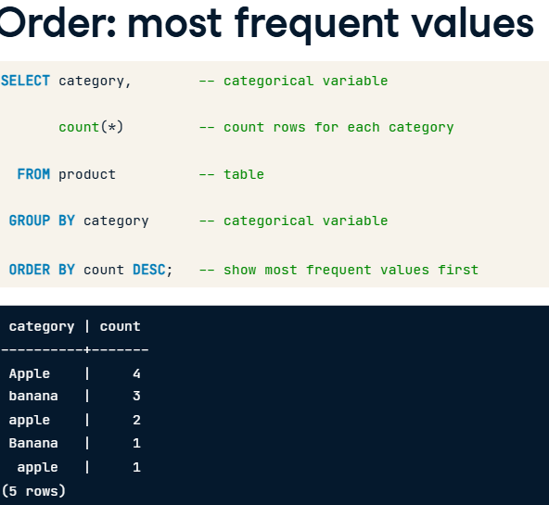

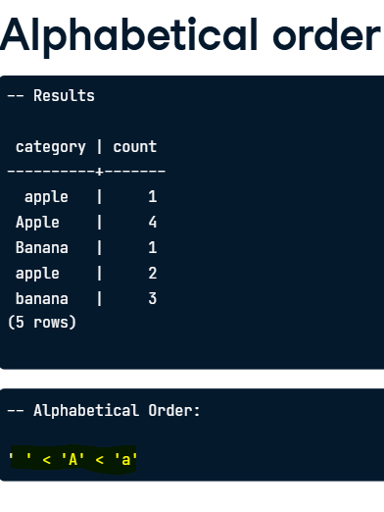

* Reminder:
  + **WHERE**: Filters rows before grouping. It cannot use aggregate functions.
  + **HAVING**: Filters groups after aggregation. It can use aggregate functions.
    - * + SELECT customer_id, SUM(amount) AS total_amount

FROM Orders

GROUP BY customer_id

HAVING SUM(amount) > 500;

**Cases and Spaces**

* Differences in spaces in a string and characters 🡪 Functions for changing the case and remove spaces (LIKE)
* Converting Case: lower() and upper()/ no affect on punctuation and numbers

* Use ILIKE, when we want to make sure upper cases are considered:

* How to clear space before and after 🡪 trim()

Code example:

SELECT distinct street,

       -- Trim off unwanted characters from street

       trim(street, '0123456789 #/.') AS cleaned_street

  FROM evanston311

 ORDER BY street;

**Splitting and concatenating text**

* Text values 🡪 break string into multiple pieces 🡪string new variable 🡪 join or concatenate string together

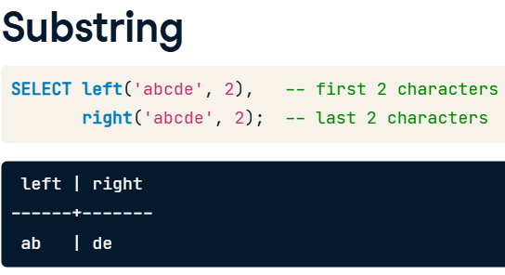

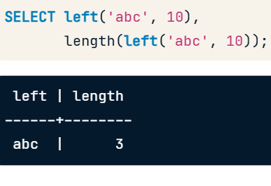

Code example:

-- Select the first 50 chars when length is greater than 50

SELECT CASE WHEN length(description) > 50

            THEN LEFT(description, 50) || '...'

       -- otherwise just select description

       ELSE description

       END

  FROM evanston311

 -- limit to descriptions that start with the word I

 WHERE description LIKE 'I %'

 ORDER BY description;

Review CASE:

In SQL, CASE is a conditional expression that allows you to apply if-then-else logic within your queries. It evaluates conditions and returns specific values based on whether each condition is met.

In the provided SQL script:

SELECT CASE

WHEN length(description) > 50

THEN LEFT(description, 50) || '...'

ELSE description

END

**Strategies for   
Multiple Transformations**

Code Example:

-- Code from previous step **(Step0)**

DROP TABLE IF EXISTS recode;

-- **(Step1)**

CREATE TEMP TABLE recode AS

  SELECT DISTINCT category,

         rtrim(split_part(category, '-', 1)) AS standardized

  FROM evanston311;

--(**Step2)**

UPDATE recode SET standardized='Trash Cart'

 WHERE standardized LIKE 'Trash%Cart';

UPDATE recode SET standardized='Snow Removal'

 WHERE standardized LIKE 'Snow%Removal%';

UPDATE recode SET standardized='UNUSED'

 WHERE standardized IN ('THIS REQUEST IS INACTIVE...Trash Cart',

               '(DO NOT USE) Water Bill',

               'DO NOT USE Trash', 'NO LONGER IN USE');

-- Select the recoded categories and the count of each (**Step3)**

SELECT standardized, COUNT(*)

-- From the original table and table with recoded values

  FROM evanston311

       LEFT JOIN recode

       -- What column do they have in common?

       ON evanston311.category=recode.category

 -- What do you need to group by to count?

 GROUP BY standardized

 -- Display the most common val values first

 ORDER BY count DESC;

**Chapter4**

**Date/time types and formats**

* Date and timestamp

* Intervals, time duration!

Example code:

-- Select the category and the average completion time by category

SELECT category,

       AVG(date_completed - date_created) AS completion_time

  FROM evanston311

 GROUP BY category

-- Order the results

 ORDER BY completion_time DESC;

-- Select the current timestamp,

-- and the current timestamp + 5 minutes

SELECT now(), now() + '5 minutes'::interval;

**Date/time components  
 and aggregation**

* Extract component, truncate the value, aggerate the value --> time fields

Example of code:

-- Select name of the day of the week the request was created

SELECT to_char(date_created, 'day') AS day,

       -- Select avg time between request creation and completion

       AVG(date_completed - date_created) AS duration

  FROM evanston311

 -- Group by the name of the day of the week and

 -- integer value of day of week the request was created

 GROUP BY to_char(date_created, 'day'), EXTRACT(dow FROM date_created)

 -- Order by integer value of the day of the week

 -- the request was created

 ORDER BY EXTRACT(dow FROM date_created);

**Aggregate with Date/time Series**

* The Generate Series only accept **timestamps** (in Python: np.linspace() )

**Using COALESCE** in a simple SQL query:

**Example Table**

Suppose we have a table called employees with the following data:

| **employee_id** | **first_name** | **middle_name** | **last_name** |
| --- | --- | --- | --- |
| 1 | John | NULL | Doe |
| 2 | Alice | Marie | NULL |
| 3 | Bob | NULL | Smith |
| 4 | NULL | NULL | Lee |

**Using COALESCE to Get Full Name**

We want to create a new column, preferred_name, that uses the first available non-NULL name in this order: first_name, middle_name, last_name.

SELECT

employee_id,

COALESCE(first_name, middle_name, last_name) AS preferred_name

FROM

employees;

**Result**

| **employee_id** | **preferred_name** |
| --- | --- |
| 1 | John |
| 2 | Alice |
| 3 | Bob |
| 4 | Lee |

Comprehensive example:

-- generate series with all days from 2016-01-01 to 2018-06-30

WITH all_days AS – (subqueries!- First subquery)

     (SELECT generate_series('2016-01-01',

                             '2018-06-30',

                             '1 day'::interval) AS date),

     -- Subquery to compute daily counts

     daily_count AS – (Second subquery)

     (SELECT date_trunc('day', date_created) AS day,

             count(*) AS count

        FROM evanston311

       GROUP BY day)

-- Aggregate daily counts by month using date_trunc

SELECT date_trunc('month', date) AS month,

       -- Use coalesce to replace NULL count values with 0

       avg(coalesce(count, 0)) AS average

  FROM all_days

       LEFT JOIN daily_count

       -- Joining condition

       ON all_days.date=daily_count.day

 GROUP BY month

 ORDER BY month;

**Purpose of COALESCE(count, 0)**

In SQL, NULL represents a missing or undefined value. However, NULL values can complicate calculations because most arithmetic operations involving NULL also return NULL. So, COALESCE(count, 0) is used to ensure that any NULL value is treated as 0 instead.

**How COALESCE(count, 0) Works**

1. **If count is NULL**, COALESCE(count, 0) returns 0.
2. **If count has a numeric value**, it returns that value as-is.

**Why It’s Useful in Aggregations**

Without COALESCE(count, 0), any NULL values in count would be excluded in calculations (like SUM, AVG, etc.), which could give inaccurate results. By replacing NULL with 0, you ensure that days without data are considered as having a count of 0 rather than being ignored.

**Example**

Consider this simplified example:

| **day** | **count** |
| --- | --- |
| 2023-01-01 | 5 |
| 2023-01-02 | NULL |
| 2023-01-03 | 3 |

Using COALESCE(count, 0), the values would become:

| **day** | **count** |
| --- | --- |
| 2023-01-01 | 5 |
| 2023-01-02 | 0 |
| 2023-01-03 | 3 |

Now, if you calculate the average count for these days, it will include the day with 0 (instead of skipping it as NULL). This way, all days are accounted for in the calculation.

**Time between events**

* Lead and lag functions

Code example:

-- Compute the gaps

WITH request_gaps AS (

        SELECT date_created,

               -- lead or lag

               lag(date_created) OVER (ORDER BY date_created) AS previous,

               -- compute gap as date_created minus lead or lag

               date_created - lag(date_created) OVER (ORDER BY date_created) AS gap

          FROM evanston311)

-- Select the row with the maximum gap

SELECT *

  FROM request_gaps

-- Subquery to select maximum gap from request_gaps

 WHERE gap = (SELECT MAX(gap)

                FROM request_gaps);

Code example2:

-- Compute monthly counts of requests created

WITH created AS (

       SELECT date_trunc('month',date_created) AS month,

              count(*) AS created_count

         FROM evanston311

        WHERE category='Rodents- Rats'

        GROUP BY month),

-- Compute monthly counts of requests completed

      completed AS (

       SELECT date_trunc('month',date_completed) AS month,

              count(*) AS completed_count

         FROM evanston311

        WHERE category='Rodents- Rats'

        GROUP BY month)

-- Join monthly created and completed counts

SELECT created.month,

       created_count,

       completed_count

  FROM created

       INNER JOIN completed

       ON created.month=completed.month

 ORDER BY created.month;

